Andre Miranda
CS-360 Mobile Architect & Programming
Professor Reuben Wilson
January 24, 2026

UI Redesign: Reddit Home Feed

I selected the Reddit Home Feed as the mobile app screen to redesign. This screen serves as the primary interface where users browse posts, discover communities, and engage with content. However, the current design includes advertisements, promotional banners, and visually distracting elements that interrupt the natural reading flow. My redesign focuses on improving clarity, reducing cognitive load, and enhancing usability while maintaining the app’s core purpose. These decisions are grounded by the principles outlined in the Android Design Guidelines (Android Developers, n.d.) and the design concepts emphasized in Mobile Architecture and Programming by McCown (2023).
The redesigned interface begins with a simplified top bar that includes the Reddit logo, a rounded rectangle style search bar, and a profile icon. Directly beneath the header, I introduced a new “Focus Mode” button similar in function to the Outlook focus mailbox. When selected, Focus Mode hides awards, trending banners, and promotional elements and shows you just your Reddit feed.
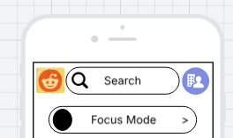
Below the Focus Mode toggle, I added a horizontal row of Quick Filters including Hot, New, Top, and Favorites, “FAV.” These filters replace the space previously occupied by ads and offer a more touch friendly component. The circle shaped buttons provide clear visuals and allow users to refine their feed with a single tap.
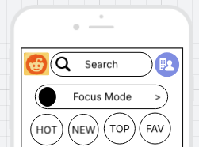
To replace intrusive advertisements, I introduced a small “Recommended Communities” section. This section is minimal, offering three community suggestions with small thumbnail style view. This feature supports user needs by helping them discover relevant spaces without disrupting the browsing experience. The bottom navigation bar remains unchanged, preserving the familiar structure of Home, Discover, Create, Chat, and Profile.
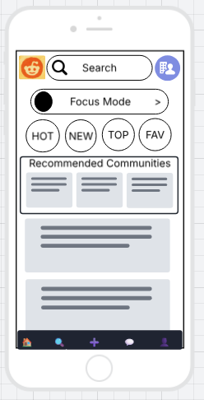
Resources:
Android Developers. (n.d.). Design guidelines. https://developer.android.com/design

McCown, F. (2023). CS 360: Mobile architecture and programming. Harding University.

